Evaporite Basins at Home
Make mineral crystals using household supplies.

Introduction
Halite is a mineral with the chemical formula NaCl, sodium (Na) chloride (Cl). Sound familiar? You probably know halite by its more common name – salt!
Halite, salt, is a type of mineral called an evaporite. Evaporites are minerals that are made out of ions that can be found dissolved in water, usually seawater. When water evaporates, it leaves these ions behind, which assemble together into evaporite minerals.
An important part of this process is the idea of solubility. You probably know that halite dissolves in water. Solubility is the measure of precisely how much of something you can dissolve in something else. The solubility of halite in water at room temperature is about 36 grams per 100 milliliters of water. That means that you could dissolve 36 grams of salt in 100 milliliters of water (that’s about ¼ cup of salt in 1 cup of water), but if you added much more salt than that, it would just sink to the bottom and never dissolve, no matter how much you stir. A solution of 100 milliliters of water and 36 grams of salt is considered saturated – no more sodium or chlorine ions can “fit” in the water.
When a saturated salt solution evaporates, water molecules go up into the air, but the sodium and chlorine ions stay behind, making the solution even saltier. Without enough water to keep all the salt dissolved, salt will begin to precipitate out of the solution – that just means the salt will “un-dissolve” out of the water! Crystals of halite will start to grow!
You can make your own saturated solution at home and grow your own crystals of halite.

Materials
- 1 clean glass jar or drinking glass (pint or quart)
- 1 pencil, skewer, chopstick, or other stick-like apparatus
- About 1 foot of thread / string
- Plain salt (between 1/4 cup and 2/3 cup, depending on salt type and glass size)
- Water

Activity
- Add 1, 2, or 3 cups of water to the glass, depending on the size of the glass.
- Add an amount of salt to the water. The amount depends on how much water you added and what kind of salt you are using. Use this chart to figure out how much salt to add:
 | 1 cup water | 2 cups water | 3 cups water
Fine table salt | 1/4 cups salt | 1/2 cups salt | 3/4 cups salt
Coarse kosher salt | 1/3 cups salt | 2/3 cups salt | 1 cup salt
- Stir the salt into the water until it dissolves. This may take a long time! Don’t give up! Remember, you’re trying to cram as much salt into this water as will possibly fit. If you really make a good effort for 10 minutes and there are still grains of salt remaining, go ahead and add a little water and stir until the salt dissolves. Too much water is better than not enough.
- Tie your string around the middle of your pencil / chopstick / skewer and place it over the mouth of the glass so the string hangs down into the solution. Trim the string so it doesn’t touch the bottom of the glass.

- Set the glass somewhere it won’t be disturbed for a couple weeks. Somewhere in the open air and in the light works best.

Analysis
You’ve just created an evaporite basin – an environment that becomes saltier and saltier over time because of evaporation. Halite forms in evaporite basins like the Dead Sea or the Mediterranean Sea, and in some time it will form in your glass, too.

Keep Track
- On what date did you set up your evaporite basin?

- On what date did you observe the first precipitated halite?
  - Where did the halite form? (at the bottom of the glass? On the string?)
  - What does the halite look like?
- Come back in another week. Where is halite forming now?
  - Has anything changed about its appearance?
- Note any other interesting observations you may make.

Evaporite Basins in Real Life
The Mediterranean Sea is a large body of salty water nestled between Europe and Africa. Seawater enters the Mediterranean Sea through a tiny, 9-mile gap between Spain and Morocco called the Strait of Gibraltar. The main way water leaves the Mediterranean Sea is by evaporation. This evaporation leaves behind the ions that make all kinds of evaporites – not just salt, but minerals like calcite and gypsum too. At some points in the past, the flow of new water into the Mediterranean from the Atlantic has slowed down, or even stopped, and the Mediterranean has dried up, possibly even completely! These periods left behind massive evaporite deposits that are now buried under the sediment at the bottom of the Mediterranean Sea.
How do you study evaporite formations that are not only underground, but under a sea? Geologists have mapped studied these deposits by drilling for “core” (rock samples) beneath the seafloor using special ships like the Glomar Challenger (left). Yes, that’s a giant drilling platform built right onto a ship!
The map below shows the extent of some of these formations. The light red color represents halite – yes, salt! Enough salt to bury the United States under a layer 100 meters thick!
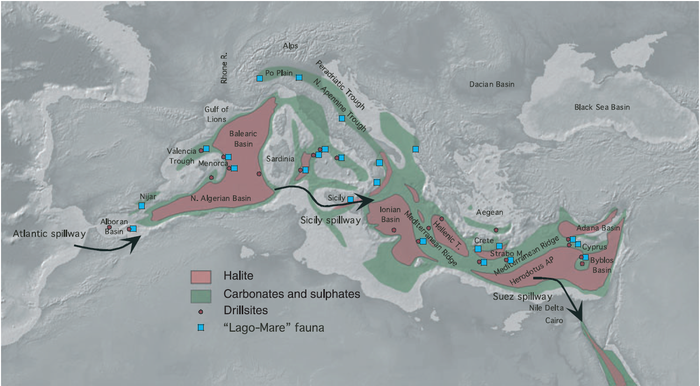
Figure 1. Map of extents of evaporites formed during a particularly dry, salty time 5 million years ago.
(Ryan, 2009. "Decoding the Mediterranean Salinity Crisis")

